PSHE POLICY
Including
Relationships and Sex Education

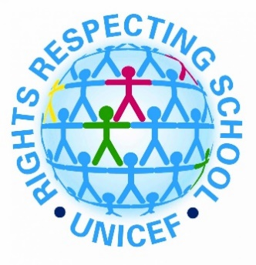
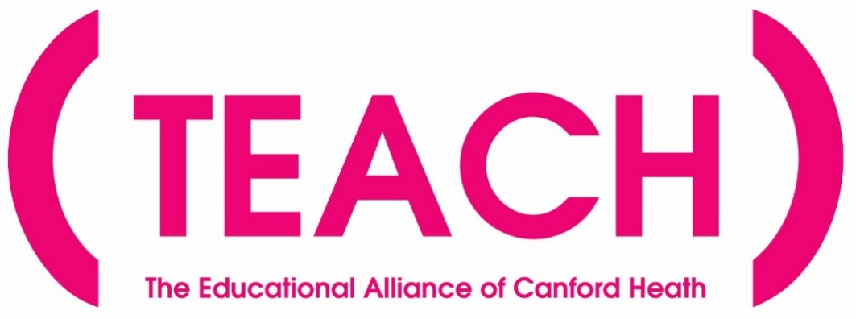

TEACH Trust Personal, Social, Health and Economic Education (PSHE) Policy
Including Relationships and Sex Education (RSE)

Statement of Intent
Our mission is to promote a love of learning in order to maximise the life chances of every child in our Trust. Through nurturing, high expectations and skilled teaching, we will have a lasting and positive impact on our local and wider community.
Our Vision
The TEACH Trust supports our children to become empowered citizens that make a meaningful contribution to society. Our curriculum reflects our locality and all it offers and aims to educate all children in matters which affect humanity in the wider world: these include all matters that relate to the climate and the world around us, such as climate change; the importance of respecting and celebrating the importance of equality and diversity; and being responsible global citizens.
We have the highest aspirations for our children: the broad and balanced curriculum promotes learning, provides cultural capital and supports spiritual, moral, social and cultural development. The Rights Respecting Gold awards and Anti Bullying awards reflect some of many ways in which education for character are integral to the work of our schools and highlights our focus on the children’s personal development.
We aim to inspire our children to be socially conscious individuals who make a difference to the world. All our children secure the key learning and skills they will need to become lifelong learners and gain employment. Our ultimate aim is to improve all our children’s life chances and prepare them to thrive in their future lives.
Under the Equality Act 2010 and the Public Sector Equality Act which came into force in April 2011, the Trust has due regard to the need to eliminate discrimination, advance equality of opportunity and foster good relations.

Statutory Requirements

All schools must provide a curriculum that is broad, balanced and meets the needs of all pupils. Under section 78 of the Education Act 2002 and the Academies Act 2010, a PSHE curriculum:

- Promotes the spiritual, moral, cultural, mental and physical development of pupils at the school and of society, and
- Prepares pupils at the school for the opportunities, responsibilities and experiences of later life.

The Relationships Education and Sex Education (RSE), and Health Education (England) Regulations 2019 have made Relationships and Health Education compulsory in all primary schools. As a primary academy, we must provide relationships education to all children as per Section 34 of the Children and Social work act 2017. In teaching relationships education, statutory guidance from the Department for Education issued under Section 80A of the Education Act 2002 and section 403 of the Education Act 1996.
All aspects of PSHE teaching and learning adhere to the statutory requirements of Keeping Children Safe In Education (KCSIE gov.uk 2025).

Non-Statutory Guidance
Although we are not required to provide sex education, we do need to teach the elements of sex education contained in the national curriculum for science, which states that children should be taught to:
- describe the changes as humans develop to old age
- describe the life process of reproduction in some plants and animals

Non-statutory guidance documents which have been considered in the creation of this policy are as follows:
- Sharing nudes and semi-nudes: advice for education settings working with children and young people (DfSI&T 2024)
- Behaviour in schools (DfE 2024)

Aims of PSHE Education
Through high quality PSHE education, TEACH Trust schools aim to achieve the following:
- Create a safe, happy and positive environment that values and inspires lifelong learning within the whole school community.
- Support pupils to become responsible, respectful and active citizens by developing the knowledge, understanding, attitudes, values and skills they need in order to reach their potential as individuals and within the community
- Develop pupils’ confidence, resilience and knowledge so they can keep themselves mentally healthy, reflect on their learning, develop independence and co-operate well with others
- Equip children with the skills to reflect on their experiences and understand how they are developing personally and socially, tackling many of the spiritual, moral, social and cultural issues that are part of growing up.
- Enable children to understand and respect our common humanity; diversity and differences so that they can go on to form the effective, fulfilling relationships that are an essential part of life and learning.
- Promote high aspirations and begin preparation the next phase of education, training, work and adulthood.
- Enable pupils to recognise online and offline risks to their wellbeing and making them aware of support that is available.
- Develop children’s understanding of how to stay physically and mentally healthy and how this can support them to thrive in their daily lives.

The TEACH Trust PSHE curriculum will support the development of the skills, attitudes, values and behaviours, which enable pupils to achieve the following:
- Have a sense of purpose
- Value self and others
- Form relationships
- Make and act on informed decisions
- Communicate effectively
- Work with others
- Respond to challenge
- Be an active partner in their own learning
- Be active citizens within the local community
- Explore issues related to living in a democratic society
- Become mentally and physically healthy and fulfilled individual

PSHE Curriculum Overview
Each year group engages in the same theme for learning each half term, and, where appropriate, these make use of resources from the nationally recognised, Jigsaw, programme for PSHE. This ensures that clear links are made to prior learning and this is revisited and built upon as children progress through their primary schooling. The PSHE curriculum also incorporates resources from the nationally recognised, Trickbox emotional management programme and the Stormbreak approach to mentally healthy movement.

Term | Theme | Content
Autumn 1 | This is me | Includes understanding my place in the class, school and global community as well as devising Learning Charters.
Autumn 2 | Celebrating Difference | Includes anti-bullying (cyber and discriminatory bullying included) and diversity work.
Spring 1 | Aspirations | Includes goal-setting, aspirations, working together to design and organise fund-raising events.
Spring 2 | Health and Wellbeing | Includes self-esteem and confidence as well as healthy lifestyle choices. Includes drugs and alcohol education (see appendix 3).
Summer 1 | Relationships | Includes understanding friendship, family and other relationships, conflict resolution and communication skills.
Summer 2 | Changes | Includes transition to a new year group or school. Includes Relationship and Sex Education in the context of looking at change.

The Learning Environment
Establishing a safe, open and positive learning environment based on trusting relationships between all members of the class, adults and children alike, is vital. To enable this, each class collaborates to devise their own class charter at the beginning of the academic year, which gives children shared ownership of a set of ‘ground rules’ to guide their behaviour in all aspects of school life, including PSHE education.
The class charter is regularly referred to during lessons to reiterate expectations and agreed behaviours.

Teaching Sensitive and Controversial Issues
Sensitive and controversial issues are certain to arise in learning from real-life experience. Teachers are trained and prepared to handle personal issues arising from the work, to deal sensitively with, and to follow up appropriately, disclosures made in a group or individual setting. Issues that we address that are likely to be sensitive and controversial because they have a political, social or personal impact or deal with values and beliefs include the following: family lifestyles and values, physical and medical issues, financial issues, bullying and bereavement.
Teachers will take all reasonable, practical steps to ensure that, where political or controversial issues are brought to pupils’ attention, they are offered a balanced presentation of opposing views. Teachers will adopt strategies that seek to avoid bias on their part and will teach pupils how to recognise bias and evaluate evidence. Teachers will seek to establish a classroom climate in which all pupils are free from any fear of expressing reasonable points of view that contradict those held either by their class teachers or their peers.

Answering Difficult Questions and Sensitive Issues

Staff members are aware that views around topics explored in PSHE are varied. However, while personal views are respected, all themes are taught without bias. Topics are presented using a variety of views and beliefs so that pupils are able to form their own, informed opinions but also respect that others have the right to a different opinion.
Both formal and informal content arising from pupils’ questions are answered according to the age and maturity of the pupil(s) concerned. Questions do not have to be answered directly and can be addressed individually later. The Trust believes that individual teachers must use their skill and discretion in this area and refer to the Designated Safeguarding Lead if they are concerned.
Our Trust believes that PSHE education and SRE should meet the needs of all pupils, answer appropriate questions and offer support. Age-appropriate curriculum content deals honestly and sensitively with sexual orientation, answers appropriate questions and offers support. Discrimination is dealt with strongly yet sensitively, in accordance with the TEACH child protection policy and the TEACH equalities policy.

Confidentiality and Child Protection
It is recognised that, on occasion, concerns may be raised over specific issues relating to the children’s lives. These may include child protection and confidentiality issues. Sometimes it is clear that certain children may need time to talk one-to-one after the class discussion closes. It is important to allow the time and appropriate staffing for this to happen. If disclosures occur, the school will follow the appropriate procedures relating to confidentiality and child protection, as per the Child Protection and Safeguarding Policy. All child protection concerns will be referred to the school’s Designated Safeguarding Lead (DSL).

Provision for children with Special Educational Needs and Disabilities (SEND)
Planning for all PSHE lessons takes account of the needs of all children. Task design to accompany key learning is adapted as appropriate to minimise barriers to learning arising from particular learning or participatory needs. Through carefully planned methods of delivery, such as discussion, group-work and creative expressions, all children are able to achieve the key learning and work to their full potential.

External Contributors
External contributors from the community, e.g. health promotion specialists, school nurses, and community police and fire officers, make a valuable contribution to the PSHE programme. Their input is carefully planned and monitored so as to fit into and complement the programme.
School staff MUST always be present during these sessions and remain responsible for the delivery of the PSHE programme.

Involving Parents and Carers
TEACH Trust schools believe that it is important to have the support of parents, carers and the wider community for the PSHE programme. Parents and carers are given the opportunity to find out about and discuss the PSHE programme through the following opportunities:
- Parents’/carers’ evenings (at junior schools)
- Involvement in policy development
- Involvement in curriculum development
- Information letters sent home

Assessment and Reporting to Parents and Carers
There are no national level descriptors for PSHE. Teachers will use professional judgement to assess children’s progress across the year and report on children’s ability to achieve the following:
- reflect on personal experiences
- develop as active and responsible citizens
- demonstrate mutual respect and tolerance
- demonstrate empathy
- question and be curious and work collaboratively.

Pupil Consultation

Pupil voice is a core value as Rights Respecting Schools and children contribute to many aspects of school life that develop their Personal, Social and Health Education. Each September, pupils agree class behaviour charters with their peers and teacher and contribute to charters as the need arises, such as football charters to guide appropriate social behaviours in specific contexts. Children are empowered to vote for their school council members and house captains (in the junior schools) each year and democracy is explored through British Values.
Relationships and Sex Education
The aims of relationships and sex education in the TEACH Trust are to achieve the following:
- Provide a framework in which sensitive discussions can take place
- Help children develop feelings of self-respect, confidence and empathy
- Make a significant contribution to the development of the personal skills needed by children if they are to establish and maintain relationships
- Create a positive culture around issues of sexuality and relationships
- Enable children and young people to make responsible and informed decisions about their health and well-being.
- Teach children the correct vocabulary to describe themselves and their bodies
- Prepare children for puberty, and give them an understanding of sexual development and the importance of health and hygiene
- Develop children’s understanding of the different protected characteristics and the importance of equality and diversity

RSE Curriculum
Broadly based on the content of the commercially published Jigsaw PSHE programme, key aspects of relationships education are delivered through the ‘Relationships’ and ‘Changes’ units of study taught in the summer term. Biological aspects of relationships education are taught within the science curriculum, and other aspects are included in Religion and Worldviews education. Relationships education focuses on teaching the fundamental building blocks and characteristics of positive relationships including the following:
- Families and people who care for me
- Caring friendships
- Respectful relationships
- Online relationships
- Being safe

The ‘Changes’ unit of learning within our PSHE curriculum is progressive across each year group, and looks at change, and coping with change, in a range of age-appropriate contexts. This forms a reassuring framework for learning about changes as we grow up and enter puberty.
See appendix 1 for further content.

Prior Notice of RSE Curriculum Delivery
The TEACH Trust liaises with parents/carers regarding the following:
- When relationships education lessons will occur in school.
- The context of the relationships education curriculum .
- Their right to withdraw their children from sex education content taught outside what is specified in the National Curriculum Science objectives.
- The process by which they can withdraw their children.
- How questions of a sensitive nature are dealt with.

Children Withdrawn from Lessons
It is important to note that the Relationships Education at our Trust sits within the Trust values framework and that we consider it vital to do this work in partnership with parents and carers. Parents do not have the legal right to withdraw their children from Relationships and Health Education. We are mindful that parents do have the legal right to withdraw their children from the components of sex education within the PSHE Curriculum, whilst we hope they do not feel the need to do so, as one without the other can be problematic.
Parents wishing to withdraw their children from lessons should write a letter to the class teacher, informing them of their wishes. The class teacher must pass this information onto the PSHE co-coordinator and the Headteacher. The Headteacher may contact the parent(s) to discuss their decision prior to the lessons being taught. Children withdrawn from the programme of study will be given alternative work to do, in another class, for the duration of the programme.

Drug and Alcohol Education See appendix 2 for further content
This policy uses the definition that a drug is ‘a substance people take to change the way they feel, think or behave’ (United Nations Office on Drugs and Crime). The term ‘Drugs’ includes the following:
- All illegal drugs
- All legal drugs including alcohol, tobacco and volatile substances which can be inhaled
- All over-the-counter and prescription medicines

Effective Drug and Alcohol Education can make a significant contribution to the development of the personal skills needed by pupils as they grow up. It also enables young people to make responsible and informed decisions about their health and well-being.

Moral and Values Framework

The Drug and Alcohol Education programme at our school reflects the school ethos and demonstrates and encourages the following values:
- Respect for self
- Respect for others
- Responsibility for their own actions
- Responsibility for their family, friends, schools and wider community

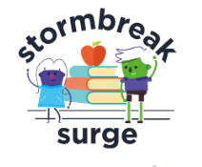
Children’s mental health and wellbeing
‘Good mental health is important for helping children and young people to develop and thrive.’ (Public Health England and DfE, 2021) Promoting children’s mental health and wellbeing is integral to keeping them safe; helping them develop as individuals and ensuring they have positive outcomes into adulthood.
At TEACH Trust, we promote positive mental health and emotional wellbeing in all staff and children and increase understanding and awareness of common mental health issues. This includes enabling staff to identify and respond to early warning signs of mental ill health in children and understanding how and when to access support. Through a culture of mental health being ‘everyone’s responsibility’, we aim to develop resilience amongst children, raising awareness of what support is available and teaching effective strategies to cope with challenges.
Our PSHE curriculum teaches the skills, knowledge and understanding our children need to keep themselves - and others - physically and mentally healthy and safe. As a Trust, we use the research-based programme ‘Trick Box’ to teach simple strategies to our children so that they can develop confidence, emotional regulation techniques, positive communication skills and creative problem-solving skills.
The strategies, or ‘tricks’, are progressive and build over time throughout the children’s academic journey. This evidence-based emotional management and personal development programme aims to support children and their families, in line with DFE guidelines.
We also facilitate Happy Habits assemblies in each year group, which focus on helping children get the best from life, manage their challenges and know when to ask for help.

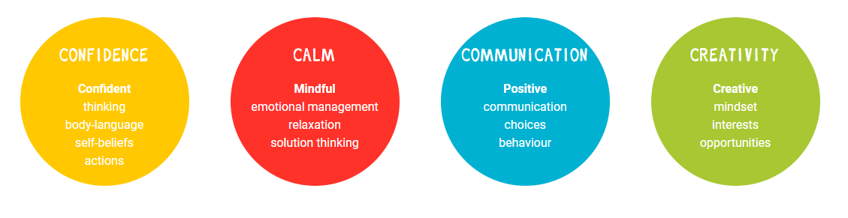

All staff will receive regular training about recognising and responding to mental health issues as part of their regular child protection and safeguarding training to enable them to keep pupils safe.
As part of our focus on improving children’s mental and physical health, TEACH schools apply ‘Stormbreak Surge’, a whole school approach to embedding regular, mentally healthy movement across the teaching week. Through structured opportunities, guided by the teacher, ‘Stormbreak’ activities are designed to:
- Improve children’s wellbeing, resilience, relationships, self-care, self-worth
and feelings of hope and optimism
- Support children’s physical activity and readiness for learning
- Help children to recognise, respond and regulate their emotions.

Roles and Responsibilities

The Role of the Class Teacher
The role of the class teacher is to provide engaging lessons in a safe and comfortable environment. Teachers provide experiences that will have maximum impact on learning through developing confidence, encouraging an active role and developing good, respectful relationships. The class teacher should encourage sharing ideas as part of a group, and listening and respecting the views of others. The child’s class teacher will normally deliver all relationships education lessons, within the PSHE curriculum. All adults in school are responsible for informing teachers about any concerns about the personal and social development of individual children. However, if a child makes reference to anything which gives cause for concern (e.g. sexual abuse, illegal substance use) then clearly such matters cannot remain confidential. Staff will report such incidents to the Designated Safeguarding Lead who will take appropriate action as per the school safeguarding policy.

The Role of School Leaders
The school leaders are committed to a whole school approach to PSHE that recognises the importance of children receiving consistent messages about key aspects of health and wellbeing. The school leaders place a high value on the role of relationships education.

The Role of the Subject Leaders
The responsibilities of subject leaders are as follows:
- to prepare a policy and scheme of work, evaluating and reviewing as necessary
- to co-ordinate and lead the implementation of the policy throughout the school
- to monitor, evaluate and review the teaching of relationships education throughout the school
- to scrutinise lesson plans and children’s work
- to ensure curriculum coverage by maintaining an overview of PSHE across the school
- to keep up to date with developments and use appropriately
- to support teachers in the delivery of PSHE education and RSE
- ensure staff are trained to deliver PSHE education and RSE effectively
- to liaise with colleagues in school and outside agencies as appropriate, in order to further develop the opportunities for pupil engagement
- to make information available to parents and carers about the content of sex education lessons prior to their delivery

The Role of Trustees
The role of Trustees is to ensure the provision of PSHE education is in line with the vision and values of the Trust and that it fulfils statutory government guidance for relationships and health education.

Other policies and documents to be read in conjunction with the PSHE Education Policy:

- Curriculum, Teaching and Learning Policy
- SEND/Inclusion Policy
- Child Protection and Safeguarding Policy
- Equality Policy
- Sharing nudes and semi-nudes: advice for education settings working with children and young people (DfSI&T 2024)
- Behaviour in schools (DfE 2024)
- Keeping Children Safe in Education (gov.uk 2025)

Appendix One: Relationships and Sex Education Content
The grid below summarises the content of the ‘Changes’ unit of learning within our PSHE curriculum. Content is progressive across each year group, and looks at change, and coping with change, in a range of age-appropriate contexts. This forms a reassuring framework for learning about changes as we grow up and enter puberty.

Year Group | Content | Learning Intentions  ‘Children will be able to…’
1 | Boys’ and Girls’ Bodies | identify the parts of the body that make boys different to girls and can use the correct names for these: penis, testicles, vagina, vulva, anus  respect my body and understand which parts are private
2 | Boys’ and Girls’ Bodies | recognise the physical differences between boys and girls, use the correct names for parts of the body (penis, anus, testicles, vagina, vulva, scrotum, nipples) and appreciate that some parts of my body are private  tell you what I like/don’t like about being a boy/girl
3 | How Babies Grow | understand that in animals and humans lots of changes happen between conception and growing up, and that usually it is the female who has the baby  express how I feel when I see babies or baby animals
3 | Babies | understand how babies grow and develop in the mother’s uterus and understand what a baby needs to live and grow  express how I might feel if I had a new baby in my family
3 | Outside Body Changes | understand that boys’ and girls’ bodies need to change so that when they grow up their bodies can make babies  identify how boys’ and girls’ bodies change on the outside during this growing up process  recognise how I feel about these changes happening to me and know how to cope with those feelings
3 | Inside Body Changes | identify how boys’ and girls’ bodies change on the inside during the growing up process and why these changes are necessary so that their bodies can make babies when they grow up  recognise how I feel about these changes happening to me and how to cope with these feelings
4 | Having A Baby | correctly label the internal and external parts of male and female bodies that are necessary for making a baby  understand that having a baby is a personal choice and express how I feel about having children when I am an adult
4 | Girls and Puberty | identify how a girl’s body changes in order for her to be able to have babies when she is an adult, and that menstruation (having periods) is a natural part of this  know that I have strategies to help me cope with the physical and emotional changes I will experience during puberty
5 | Puberty for Girls | identify how a girl’s body changes during puberty and understand the importance of looking after myself physically and emotionally  understand that puberty is a natural process that happens to everybody and that it will be OK for me
5 | Puberty for Boys and Girls | identify how boys’ and girls’ bodies change during puberty  express how I feel about the changes that will happen to me during puberty
5 | Conception | understand that sexual intercourse can lead to conception and that is how babies are usually made  understand that sometimes people need IVF to help them have a baby  appreciate how amazing it is that human bodies can reproduce in these ways
5 | Testicular tortion (boys only) | know that this is a medical emergency which affects 1 in 1000 males aged 10-20; how to recognise the symptoms and action to take. Delivered through NHS-endorsed materials.
6 | Puberty | recall and explain how girls’ and boys’ bodies change during puberty and understand the importance of looking after myself physically and emotionally  understand that puberty is a natural process that happens to everybody and that it will be ok for me
6 | Puberty for boys | recall and describe how boys’ and girls’ bodies change during puberty  express how I feel about the changes that will happen to me during puberty
6 | Conception | recall that sexual intercourse can lead to conception and that is how babies are usually made  recall and understand that sometimes people need IVF to help them have a baby  appreciate how amazing it is that human bodies can reproduce in these ways
6 | Testicular tortion (boys only) | know that this is a medical emergency which affects 1 in 1000 males aged 10-20; how to recognise the symptoms and action to take. Delivered through NHS-endorsed materials.
6 | Looking ahead | identify what I am looking forward to about becoming a teenager and understand this brings growing responsibilities (age of consent)  confident that I can cope with the changes that growing up will bring

Appendix Three: Drug and Alcohol Education Content
The grid below shows specific Drug and Alcohol Education learning intentions for each year group in the ‘Health and Wellbeing’ unit of learning
Year Group | Content | Learning Intentions  ‘Pupils will be able to…’
2 | Medicine Safety | understand how medicines work in my body and how important it is to use them safely  feel positive about caring for my body and keeping it healthy
3 | What Do I Know About Drugs? | tell you my knowledge and attitude towards drugs  identify how I feel towards drugs
4 | Smoking and vaping | understand the facts about smoking and its effects on health, and also some of the reasons some people start to smoke  can relate to feelings of shame and guilt and know how to act assertively to resist pressure from myself and others
4 | Alcohol | understand the facts about alcohol and its effects on health, particularly the liver, and also some of the reasons some people drink alcohol  can relate to feelings of shame and guilt and know how to act assertively to resist pressure from myself and others
5 | Smoking and vaping | know the health risks of smoking and can tell you how tobacco affects the lungs, liver and heart  make an informed decision about whether or not I choose to smoke and know how to resist pressure
5 | Alcohol | know some of the risks with misusing alcohol, including anti-social behaviour, and how it affects the liver and heart  make an informed decision about whether or not I choose to drink alcohol and know how to resist pressure
6 | Drugs | know about different types of drugs and their uses and their effects on the body particularly the liver and heart (types are distinguished as legal/illegal and prescribed/non-prescribed).  be motivated to find ways to be happy and cope with life’s situations without using drugs
6 | Alcohol | evaluate when alcohol is being used responsibly, anti-socially or being misused  tell you how I feel about using alcohol when I am older and my reasons for this

Equality Impact Assessment
Question | Response | Please tick
Which relevant groups and  stakeholders have been consulted with in relation to this policy? | Pupils
 | Trustees
 | Staff
 | Parents/Carers
 | Local Authority
 | Trade Unions
 | Other Advisors (give details)
What are the arrangements for  monitoring and reviewing the actual  impact of the policy? | Termly
 | Annually
 | When applied
 | If legislation changes
 | If a formal complaint

Does the policy affect one group less or more favourably than another on the basis of: | Y/N
Disability | No
Gender reassignment | Yes
Marriage or civil partnership | No
Pregnancy and maternity | No
Race | No
Religion or belief | Yes
Sexual orientation | Yes
Sex (gender) | Yes
Age | No
SEN | No
Vulnerable | No
Traveller, migrant, refugees and people seeking asylum | No
EAL | No

 | Y/N | Comments/Actions
Is there any evidence that some groups are affected differently? | Y | The policy may not align with RSE practices of all faiths  Content uses gendered descriptors of boys/girls
If you have identified potential discrimination, are any exceptions valid, legal and/or justifiable? | Y | Policy adheres to UK Statutory guidance, which applies gendered descriptors of boys/girls  Parental right to withdraw from sex education is detailed
Is the impact of the policy likely to be negative? | N
If yes, can the impact be mitigated by taking different action? | N/A

Date: June 2026
Review: June 2027

