CURRICULUM, TEACHING and LEARNING POLICY




Statement of Intent
Our mission is to promote a love of learning in order to maximise the life chances of every child in our Trust. Through nurturing, high expectations and skilled teaching, we will have a lasting and positive impact on our local and wider community.
Our Vision
The TEACH Trust supports our children to become empowered citizens that make a meaningful contribution to society. Our curriculum reflects our locality and all it offers and aims to educate all children in matters which affect humanity in the wider world: these include all matters that relate to the climate and the world around us, such as climate change; the importance of respecting and celebrating the importance of equality and diversity; and being responsible global citizens.
We have the highest aspirations for our children: the broad and balanced curriculum promotes learning, provides cultural capital and supports spiritual, moral, social and cultural development. The Rights Respecting Gold awards and Anti Bullying awards reflect some of many ways in which education for character are integral to the work of our schools and highlights our focus on the children’s personal development.
We aim to inspire our children to be socially conscious individuals who make a difference to the world. All our children secure the key learning and skills they will need to become lifelong learners and gain employment. Our ultimate aim is to improve all our children’s life chances and prepare them to thrive in their future lives.
Under the Equality Act 2010 and the Public Sector Equality Act which came into force in April 2011, the Trust has due regard to the need to eliminate discrimination, advance equality of opportunity and foster good relations.

Aims
Our vision for our children is that they become empowered global citizens who make a meaningful contribution to society and play their part in making the world a better place.
The aims of our school curriculum are as follows:
- to teach children about the UNCRC so that they have a respect for themselves, high self-esteem and be able to live and work co-operatively with others
- to instil a love of reading through high quality literature that unlocks imagination, expands vocabulary and provides access to unlimited discovery
- to promote a positive attitude towards learning based on the Teach Trust values, so that children enjoy coming to school and acquire a solid basis for lifelong learning
- to teach children key skills and knowledge through a broad and balanced curriculum, that fulfils the requirements of the 2014 National Curriculum, to prepare them for the modern world
- to enable children to be creative and to develop their own thinking
- to teach children how they can safeguard and enhance their physical and mental well-being

- to advance children’s cultural capital to enable them to be positive citizens in their local, national and global community
- to teach children about their developing world, including how their environment and society have changed over time
- to help children understand the importance of truth and fairness, so that they grow up committed to eradicating prejudice and celebrating diversity.
- to promote the British values of democracy, the rule of law, equality, individual liberty and mutual respect for those with different faith and beliefs

Curriculum Intent

The TEACH Trust curriculum is a purposefully planned sequence of knowledge, creativity and skills development informed by the following design principles:

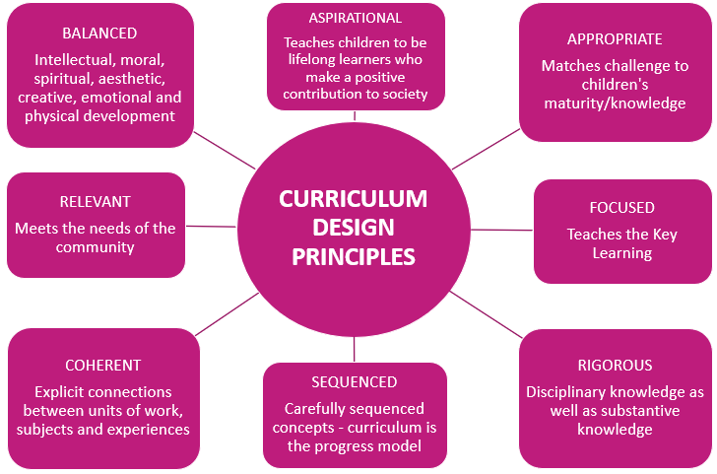

The curriculum is all the planned activities that we organise in order to promote learning, personal growth and development, including subject-specific content, enrichment opportunities and extra-curricular activities. These are combined to ensure that all children access broad and balanced key learning.

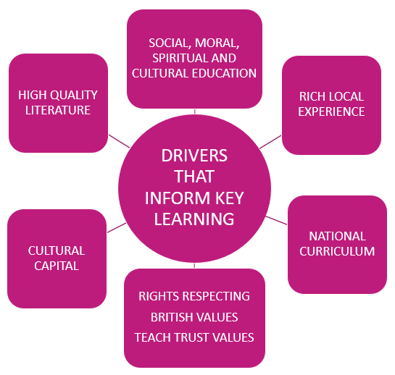

We have designed a knowledge-rich curriculum which reflects the varied experiences our locality offers and aims to educate all children in matters which affect humanity in the wider world. The curriculum is designed to challenge prejudice, promote equality and engage an ownership and love of learning so that by the end of the primary years, children can articulate their preferences, views and opinions, and begin to establish initial ideas about career choice.

Vocabulary
Research by the Education Endowment Fund has shown that high quality vocabulary teaching secures early language development and this contributes to:

- Better reasoning, inference and pragmatic skills
- Academic success and employment
- Better mental health and wellbeing

To secure understanding of content, readers need to achieve 95% comprehension. In order to equip learners with the vocabulary they need to achieve this, the curriculum design facilitates instructional teaching of a 3-tier vocabulary spine which is implemented through a high-quality reading spine and explicit teaching of subject-specific vocabulary.

Beck, I, McKeown, M.G. & Kucan, L (2002, 2008)

Teaching across the range of curriculum subjects develops breadth of vocabulary through:

- Teaching meanings and applications of subject-specific vocabulary
- Building a schema of concept vocabulary
- Extending vocabulary through alternative words with similar meanings (synonyms) and words chosen for precision

The reading spine is infused with rich vocabulary and driven by the following key considerations:

- Ensuring experience of a full variety of text complexity
- Maximising opportunities to develop factual knowledge though enriching content
- Exposure to widely read and referenced materials that demonstrate utility, significance and cultural capital
- Ensuring experience of a variety of genres
- Selection of great texts that are engaging and will inspire further reading
- Exposure to texts that children will enjoy, even if they are challenging at the outset
- Selection of texts that teachers will relish sharing with children, to instil a love of reading for pleasure

Core Subjects
In the TEACH Trust, we believe that a quality English curriculum should develop children’s love of reading, writing and discussion. From entry, high quality teaching of systematic synthetic phonics secures the foundations of early reading and access to carefully chosen reading materials supports children’s progress. We have a rigorous and well organised English curriculum that provides many purposeful opportunities in reading, writing and spoken language which progressively builds upon the key knowledge and skills the children have already acquired.
English is both a subject in its own right and the medium for teaching; we believe that fully understanding language and developing a wide and rich vocabulary provides access to the whole curriculum. Fluency in the English language and the acquisition of a breadth of vocabulary are essential foundations for success in all subjects.
When teaching mathematics in the TEACH Trust, we provide a curriculum which caters for the needs of all individuals and sets them up with the necessary skills and knowledge for them to become successful in their future adventures. We incorporate sustained levels of challenge through varied and high-quality activities with a focus on fluency, reasoning and problem solving which build progressively through the year groups.
In addition to teaching mathematics discretely, TEACH Trust teachers provide daily opportunities for the children to develop their numeracy and mathematical reasoning across a range of curriculum subjects so that our children understand and appreciate the importance of mathematics in everyday life.
Our science curriculum aims to capitalise on children’s curiosity and inspire a thirst for discovery. The carefully sequenced progression teaches investigative science and enquiry skills, enabling children to develop their knowledge and understanding of the world in which they live. Children are equipped to observe, question, investigate, make sense of and communicate and evaluate their findings. They develop a systematic and logical way of working, becoming confident, articulate and investigative learners.

Foundation subjects

Where advantageous, curriculum subjects are organised around topics as this approach supports effective learning in a number of ways:
- learners are engaged through a hook at the start of the topic and an outcome to give the learning purpose
- cross-curricular links are made in other subject lessons throughout the week: this gives opportunity to revisit new learning and aids the transfer from short to long-term memory
- children build a schema: a web of knowledge formed by linking areas of learning
- children are able to transfer skills and knowledge across subject areas: new learning is easier to secure as it connects with existing knowledge
Alongside this, some subjects are taught discretely to ensure subject-specific key learning is not diluted by tenuous or fabricated links.
Key knowledge fact sheets accompany each topic and outline the subject-specific substantive learning and vocabulary that children will learn through that topic. Throughout the course of the topic, opportunities to embed the key learning through lesson activities and regular retrieval practice will ensure that the learning is secured in children’s long-term memory. Key knowledge fact sheets are not used in every subject area as some disciplinary skills acquired through practical application do not lend themselves to consolidation through retrieval practice.

Growth Mindset
In order for all our children to be successful and resilient learners, a growth mindset must be at the heart of everything we do. We ensure children understand the processes and attitudes which lead to learning, such as concentrating, persevering and learning from mistakes. This enables children to set and monitor learning goals for themselves, and evaluate their own development.
Decades of research has evidenced that people with Growth Mindsets are more:
- open to challenges and constructively critical feedback
- resilient in the face of obstacles and initial failure
- convinced that individual effort makes a difference
- likely to attribute success and failure to their own efforts, rather than innate abilities
- able to learn well with and from others
- likely to rise to the top – and stay there.

Planning

To ensure cohesion across the schools in the Trust and across the year groups in each school, long and medium-term planning is designed by senior leaders. This, along with sharing planning responsibilities across a Trust-wide year group team, reduces teacher workload and allows teachers to focus on developing the daily lesson design to suit the needs of their particular teaching groups, and individuals.

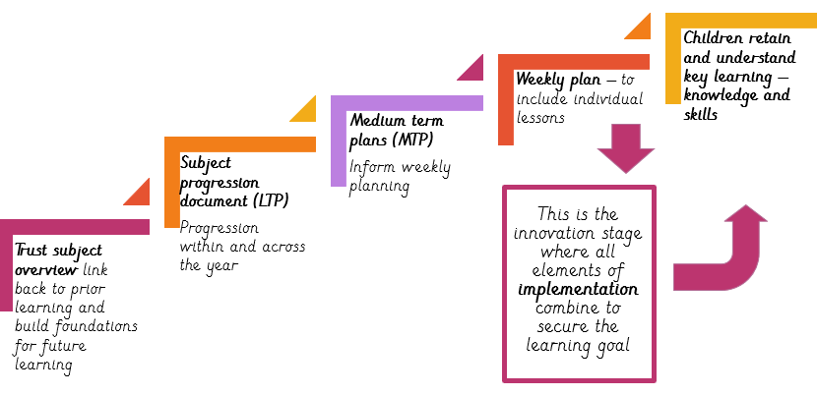

Lesson structure

All lessons apply principles of effective teaching and learning through use of retrieval practice; fluency and consolidation; direct instruction; scaffolded and independent practice and plenary.

Access and equity for all learners
All TEACH staff and Trustees have high aspirations for all children in our schools, no matter what their needs or abilities. The curriculum in our school is designed to provide inspiration, access and opportunity for all. We believe that exciting, engaging lessons, adapted individually to ensure access according to each child’s needs are the best way to ensure every child succeeds. All teachers tailor their lessons carefully to ensure that every child is challenged and supported, where appropriate, in order to maximise their potential and become confident and independent learners.
As outlined in our SEND Policy, we actively strive to enhance the equality of opportunity. Therefore, if a child has identified special needs and/or a disability, our school does all it can to meet these individual needs and remove the barriers to learning. We comply with the requirements set out in the most recent SEND Code of Practice in providing excellent pedagogy and resources for our children with special needs. Teachers provide differentiated provision, resources and educational opportunities which meet the child’s needs within the usual class organisation. Support staff or key adults may be used to assist identified groups of children, which may sometimes be in addition to the work undertaken in the classroom.
For the great majority of our children with SEND, they will be expected to know, understand and remember the key learning in every lesson. They are enabled to access the key learning through carefully planned 'ways in'. Ways in are adaptations made to lesson activities and tasks to ensure pupils with SEND can access the key learning successfully. These might include alternative ways of recording or presenting work, opportunities for practising a skill and recalling prior learning, using concrete apparatus to visualise a concept or having access to a range of learning tools such as personalised vocabulary or numeracy mats. Ways in are personalised to meet the learning needs of individual children, so a way in for one child may look different to another child’s way in.
We have a small percentage of children in each school who are not ready to meet the key learning in a lesson (e.g. some of our children with EHCPs and those working significantly below age-related expectations), and these children have bespoke, personalised provision, often with a key adult, and are working on their own learning objectives.
Appropriate adaptations are made to facilitate curriculum access by children for whom English is an additional language (EAL). This includes ongoing assessment of language acquisition to ensure that language barriers are addressed in curriculum provisions.
All children are challenged with open-ended questions and tasks and encouraged to follow lines of thought independently. They also have extra opportunities to attend out of school workshops and enrichment activities to develop their interests and skills to the full.
Year teams, with guidance, can arrange their afternoon timetables to make the most of cross-curricular opportunities and the needs of children. Sometimes subjects and activities might be ‘blocked’ or run over successive afternoons, to support children to keep focussed on concepts or to consolidate skills and to allow practical work to flow.
Planning and teaching of subjects such as PE and music is supported by subject specialists to ensure that provision is adapted to suit the needs of all children. For example, children with physical disabilities will continue to access the key learning in PE through activities that are adapted to suit their individual abilities. Within the junior schools, specialist teaching takes place in many PE and music lessons; and specialist teaching of PE and music are on offer in the extra-curricular activities in both infant and junior schools.

The Role of Class Teachers
We expect every teacher to be at least good – every child deserves that.
By adopting a whole school approach to teaching and learning in our school, we aim to do the following:
- Provide consistency of teaching and learning across all classes in all schools
- Ensure teaching and learning is as effectively as possible
- Enable children to maximise their learning to maximise their potential
- Give children the skills they require to become effective lifelong learners
- Provide an inclusive education for all children
- Learn from each other, through the adoption of a collaborative, enquiry based approach to
teaching and learning, where good practice is shared
- Provide equality and excellence for all, in order to promote the highest possible
standards.

There is no single recipe for improving teaching and learning in our Trust. However, this policy outlines some of the key elements which are vital to raising standards in teaching and learning. It also sets out a broad structure for lessons, based on best practice and research linked to how we learn best. When reading this policy it is important to remember that, as long as the key learning is met, adopting a broad template for structuring lessons does not preclude:

- Spontaneity
- Creativity
- Imagination
- Individuality

Key elements and principles of teaching and learning – a practical summary guide
All lessons across our school should include the following key elements to ensure high quality teaching and learning:

All lessons have clear learning objectives
- Learning objectives are shared with the class at the beginning or during a lesson
and children are often encouraged to identify the learning objective through
investigation.
- All children are clear about how they will achieve the learning objective (through
success criteria, toolkits, feedback, etc.).
- Children regularly self-assess or peer-assess work.

Adaptive teaching enables all children to access learning

- All learners are challenged and supported appropriately.
- Planning clearly shows the key learning children are expected to secure.
- Ways in are planned to enable all children to access the key learning.
- Planned challenges extend and deepen the learning.
- New material is presented in small steps through modelling, scaffolded and
independent practice.

Questioning is used effectively to check and deepen understanding

- Questions help children practise new information and connect new information to prior learning.
- Teachers use a range of strategies to enable all children to respond, e.g. individual
whiteboards, quizzes, summarising to a learning partner
- Process questions offer opportunity to explain the response and how the response was
reached.

All children are actively engaged in their learning

- Children are actively engaged during all parts of the lesson – teachers take into
account children’s concentration span and ensure children are not sitting passively for long periods.
- Opportunities for ‘Think/Pair/Share’ and discussion with a ‘Learning Partner’
are regular features in all lessons.
- Visual prompts, artefacts and auditory input are all used creatively as a way to
enhance learning.
- Talk for Writing is used to ensure children understand and rehearse what they
are writing before they write it.

All children receive regular and clear feedback which enhances learning

- AFL and effective feedback is embedded in everyday practice and is used to
inform teaching and learning.
- Through effective feedback and conferencing with the teacher, all children are clear about how
they need to improve.
- Feedback is linked to the learning objective and can identify areas for
improvement and feedback which is often responded to.
- Children are given appropriate time to address issues raised in marking by
Responding.
- Pit-stops in lessons enable group feedback to address common needs and
misconceptions.

Learning is enhanced through important values
- Through our teaching, children are taught to show trustworthy behaviours and teachers model this.
- Excellence is encouraged through consistently high expectations, quality first teaching and effective, timely intervention.
- Through our curriculum, enrichment and encouragement, we support children to have the highest aspirations for themselves and for their role in society.
- Teachers role model and encourage effective collaboration to develop children’s confidence and capacity to work cooperatively.
- Teachers promote, encourage and expect the enduring value of honesty amongst all members of the school community.

Children know how to learn effectively, understand more and remember more
- Teachers support children to plan, monitor and evaluate their learning.
- Teachers model their own metacognitive thinking.
- Teachers set appropriate levels of challenge to develop self-regulation.
- Motivation is promoted through wider opportunities, such as aspirations and careers education, and the growth mindset ethos.
- Teachers plan opportunities for regular practise and review.
- Vocabulary development is explicitly taught as an integral factor in understanding new information.

Set high expectations and give every learner confidence they can succeed
- Demonstrate a commitment to every learner's success, making them feel included, valued and secure.
- Raising learners' aspirations and the effort they put into learning, engaging, where appropriate, the active support of parents or carers.
- Promote a growth mindset mentality so children always want to improve and achieve to the very best of their ability.

Approach to Teaching and Learning - The Diet for Learning
Teaching and learning are not the same thing. Encountering information is not the same as understanding, remembering or applying it. While the stages are inextricably linked, they are separate processes. This must be reflected in the lesson.
Lessons might include a mixture of; whole class teaching, cut-away groups, mini plenaries and ‘pit-stops’. How we teach will determine how much our children learn. The emphasis is on our children developing understanding, skills and knowledge and on remembering it and applying it to a range of situations.
Teachers understand and apply the principles of how learning is most effective and use a range of these strategies to good effect which ensures children learn well and make at least good progress.

KNOW THE NEEDS OF THE CHILDREN
This includes the following:
- Use of a variety of techniques to assess prior learning and abilities
- Use of data from tests and planned assessments
- Quality questioning
- AfL from prior learning and marking of work
- Awareness of children’s individual learning styles
- Awareness of children’s pastoral and/or SEND needs
- Knowing the children’s capabilities and setting challenging targets for them.

KNOW WHAT THE CHILDREN NEED TO LEARN
This includes the following:
- Knowledge of the planned curriculum
- Planning teaching sequences that support and challenge
- Focus on clear, specific learning objectives
FACILITATE LEARNING (QUALITY TEACHING)
This includes the following:
- Promoting good progress and outcomes through effective planning
- Effective questioning, including open ended
- High quality marking and feedback
- Teaching others ~ encouraging pupil involvement and independence
- Discussion – quality interaction between children and staff
- Use of appropriate resources, including literature and ICT
- Encouraging risk taking
- On-going reviews within the lesson – AFL which lead to adapting the lesson to meet the needs of children
- Modelling, scaffolding and challenge of tasks
- Investigation, research, enquiry, reasoning and application of skills
- Appropriate pace / independent learning opportunities
- Knowledge/understanding of how children learn effectively and retain information

REVIEW REGULARLY

This includes the following:

- Conferencing 1:1 with the teacher
- Quality marking and feedback which is responded to
- Peer and Self- assessment
- Use of data and tracking
- Use of formative and summative assessment
- Quizzing and recall activities

The Role of Subject Leaders

The subject leader will take responsibility for leadership and management of the subject to secure the following:
- High quality teaching
- Effective use of resources
- Improved standards of learning and achievement for all

Strategic direction

The subject leader should:
- keep abreast of relevant national, local and school research pertaining to the subject area, as well as research and inspection evidence, to inform practices, expectations, and teaching methods
- access examples of good practice beyond TEACH and use this information to develop provision across all schools in our Trust
- create a climate which enables staff to develop and maintain positive attitudes towards the subject and confidence in teaching it
- establish a clear, shared understanding of the importance and role of the subject in contributing to children’s spiritual, moral, cultural, mental and physical development, and in preparing children for the opportunities, responsibilities and experiences of adult life
- use evidence effectively to identify areas of underachievement and support teachers to modify provisions accordingly
- work with SLT to monitor and evaluate the effectiveness of the teaching and learning ensuring the key learning is being taught effectively
- through pupil conferencing, identify if key learning is being retained.

Teaching and learning

The subject leader should:
- ensure all children access the planned curriculum coverage, continuity and progression in the subject
- make sure that teachers are clear about the teaching objectives in lessons, understand the sequence of knowledge and skills development in the subject, and communicate such information to children
- evaluate the teaching of the subject in the school use this analysis to identify effective practice and areas for improvement, and take action to improve further the quality of teaching
- develop effective links with the local community, including business and industry, in order to extend the curriculum, enhance teaching and to develop children’s wider understanding
- support the effective and efficient management and organisation of learning resources, including IT and enrichment opportunities.

The Role of School Leaders/ Trustees

The CEO, Headteachers, Head of Curriculum and Standards, and Head of Inclusion oversee the quality of teaching and learning in Teach Trust schools. To facilitate this, they ensure that all aspects of children’s learning provisions are matched to children’s needs and that teachers receive timely continuous professional development (CPD).

As part of this process, arrangements for the allocation of teaching classes, teaching sets and the year group each child is taught in is at the discretion of the Headteacher.

The Headteacher ensures that teaching groupings are balanced, making equitable provision in the best interests of every child. These decisions are based on a range of factors including, but not limited to the following:

- Balance of gender
- Balance of special educational needs and disabilities (SEND)
- Balance of social, emotional and mental health needs (SEMH)
- Balance of pastoral needs and other vulnerabilities
- Balance of behavioural needs
- Prior academic attainment
- Historic information which may impact the effectiveness of groupings
- Suitability of the available learning space and access to specific resourcing
- Suitability of the teacher (e.g. particular areas of expertise or additional qualifications)

Our Trustees determine, support, monitor and review school policies on teaching and learning. In particular they fulfil the following:

- to have ultimate strategic lead on the content and focus of the whole school curriculum
- to regularly review the outcomes derived from the curriculum, to ensure it remains fit for purpose
- ensure that staff development and performance appraisal policies promote high quality teaching
- to ensure sufficient time is allocated and funds and resources are available to deliver a high-quality curriculum, meeting statutory guidance
- monitor school processes in the light of health and safety regulations
- monitor the effectiveness of the school’s teaching and learning policy through school self-evaluation processes. These include reports from School Improvement Partners, Subject Leaders, Year Leaders, as well as a review of CPD sessions attended by staff.

PARENTAL INVOLVEMENT

We believe that parents have the responsibility to support their children and the school in implementing school policies. Parents are expected to fulfil the following:

- ensure that their child has the best attendance record possible
- ensure that their child is equipped for school with the correct uniform and PE kit
- do their best to keep their child healthy and fit to attend school
- inform the school if there are matters outside of school that are likely to affect a child’s performance or behaviour at school
- promote a positive attitude towards school and learning in general
- ensure their child participates in remote learning if they are unable to attend school due to national restrictions.

In addition to this, the school will keep parents informed about their child’s learning in the following ways:

- informing them every term of their child’s progress either through written or verbal reports or meetings, including consultation evenings twice per academic year
- providing information about the curriculum and homework via the school website and email
- communicating with parents for example through a homework diary
- being available to meet with parents in a reasonable timescale, as requested
- providing training and advice about teaching and learning to parents throughout the year, e.g. reading and maths workshops.

Other policies and documents to be read in conjunction with the curriculum policy:

- National Curriculum
- SEND Inclusion Policy
- Equal Opportunities Policy
- Rights’ Respecting Policy

Monitoring and review

The monitoring of the implementation of this policy is the responsibility of the Trustees, CEO, Headteachers, Head of Curriculum and Standards, and Head of Inclusion.

Reviewed March 2025

Equality Impact Assessment

Question | Response
Which relevant groups and  stakeholders have been consulted with in relation to this policy? |  | Please tick
 | Pupils
 | Trustees
 | Staff
 | Parents/Carers
 | Local Authority
 | Trade Unions
 | Other Advisors (give details)
What are the arrangements for  monitoring and reviewing the actual  impact of the policy? | Termly
 | Annually
 | When applied
 | If legislation changes
 | If a formal complaint

Does the policy affect one group less or more favourably than another on the basis of: | Y/N
Disability | Y
Gender reassignment | N
Marriage or civil partnership | N
Pregnancy and maternity | N
Race | N
Religion or belief | N
Sexual orientation | N
Sex (gender) | N
Age | N
SEN | Y
Vulnerable | Y
Traveller, migrant, refugees and people seeking asylum | N
EAL | Y

 | Y/N | Comments/Actions
Is there any evidence that some groups are affected differently? | Y | Curriculum adaptations are made in relation to specific needs
If you have identified potential discrimination, are any exceptions valid, legal and/or justifiable? | Y | Statutory SEND Code of Practice
Is the impact of the policy likely to be negative? | N
If yes, can the impact be mitigated by taking different action? | N/A

